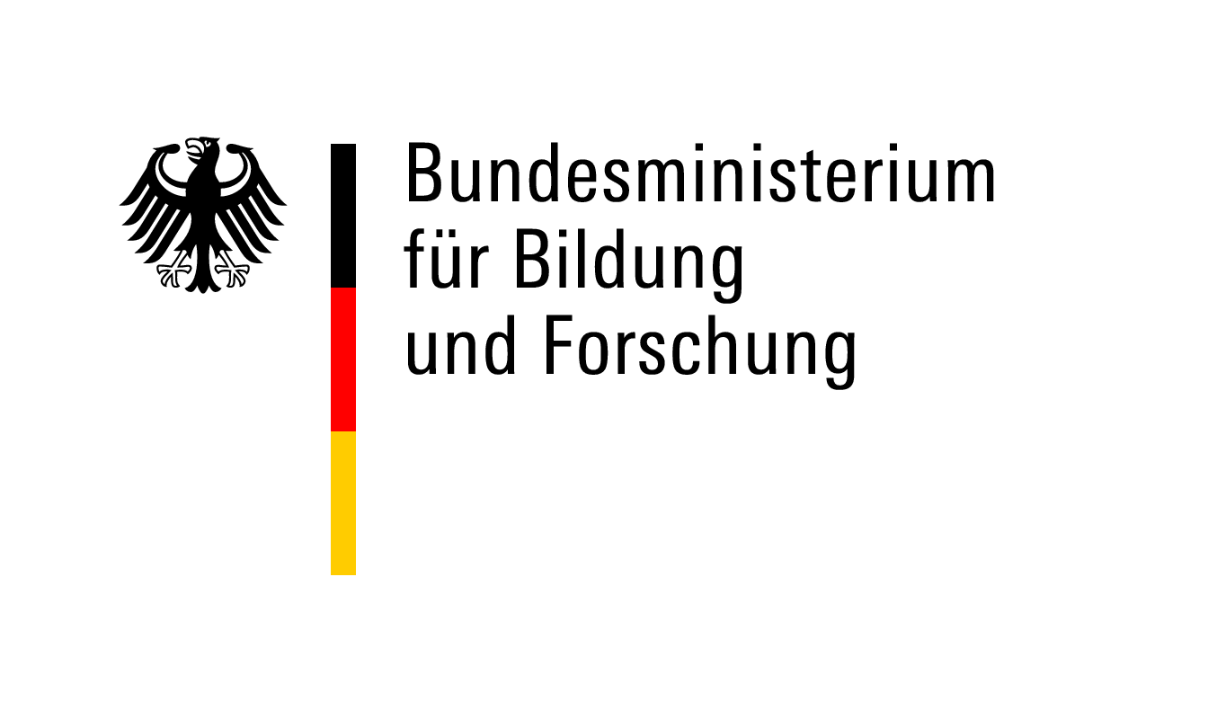

Checklist – Application Documents
Postdoctoral Researchers International Mobility Experience (PRIME)

Documents to be uploaded to the DAAD Portal:

Application form
CV
Short summary of the research project
Detailed research proposal
Time schedule
Binding declaration from the German host university (form 1)
Invitation letter from the German host (form 2)
Invitation letter from the foreign host
Degree certificates
Master (or equivalent) with transcripts of records
PhD with transcripts of records (if available)
If PhD not yet completed, statement from PhD supervisor on expected time of completion
Publication list
List of the most important publications (min.1, max. 3) with reasons for their selection
Short summary of the doctoral thesis
Supplementary information (if applicable)
Ethics issues checklist (form 3)
Language certificate for the period abroad (if applicable)
Language certificate for German (if applicable)
Reference letter requested (will be sent by post)

I have taken note of the call for applications and the programme FAQs. I am aware that only complete applications will be processed. Applications that are incomplete or non-compliant with the programme regulations will not enter the review process.

Place/Date Signature of Applicant

